School:_________________ Name of learner: __________________________
Grade 2 Term 2 Week 1 - 2
Life Skills Low support group
Topic: Seasons Date: __________________
Educator:________________
Formal assessment goal: Know how seasons affect our food intake

Task 1: Colour the food pictures that you will eat during summer and winter
Summer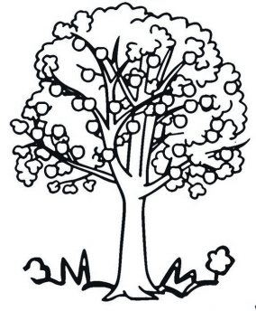
    ice cream | 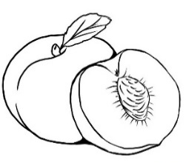peaches
  Milo | 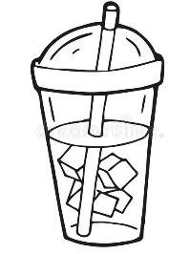cold drink
Winter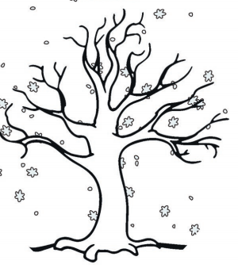
  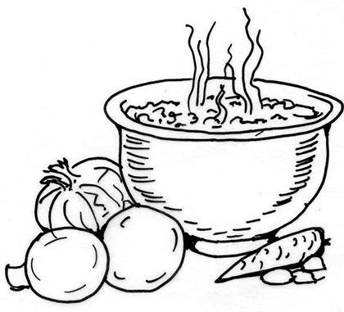soup | 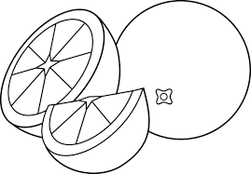oranges
    Hot choco-late | 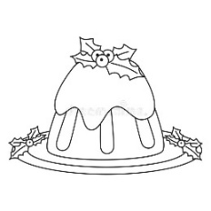Christmas pudding
Correct answers | 1 | 2 | 3 | 4 | 5 | 6
Rating code | 1 | 2 | 4 | 5 | 7 | 7
Formal assessment tool: Teacher marks the correct answers and use the conversion table to arrive at a rating code

School:_________________ Name of learner: __________________________ Grade 2 Term 2
Week 1-2 Date: __________________ Life Skills Low support group
Topic: Seasons Educator:________________
Formal assessment goal: Know how seasons affect our clothes
Task 2: Cut, match and paste the clothes to wear during the seasons
Spring | Summer | Autumn | Winter
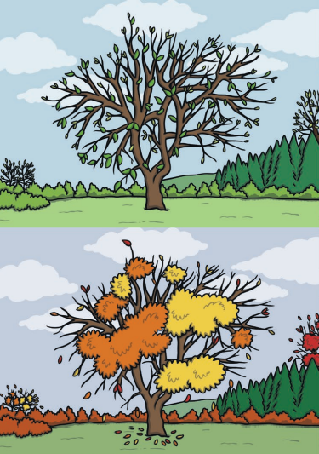 | 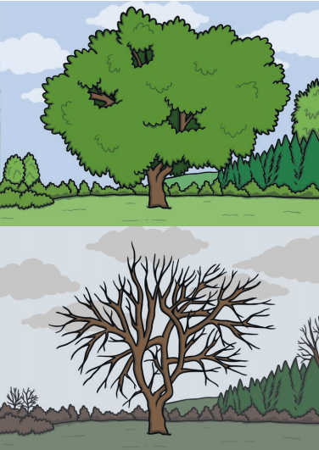
Paste your pictures here | Paste your pictures here | Paste your pictures here | Paste your pictures here

Formal assessment tool: Teacher marks correct answers to arrive at a rating code

Cut the pictures and paste in the correct spaces on the previous page

---------------------------------------------------------------------------------------------------------------------------

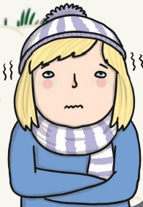 | 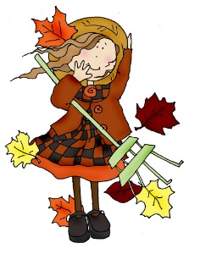 | 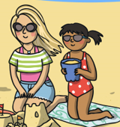 | 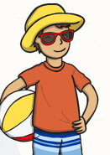 |  | 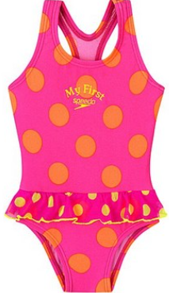 | 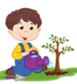

School:_________________ Name of learner: __________________________
Grade 2 1st year Term 2 Week 3-4
Life Skills Low support group
Topic: Creatures living in water Date: __________________
Educator:________________
Formal assessment goal: Identify and label water animals
Task 3: Identify and label water animals. Use the words in the word box.
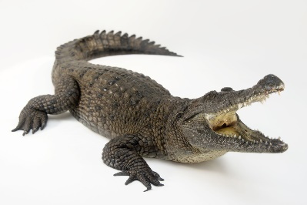 | 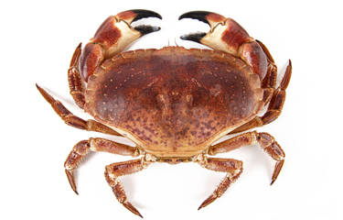 | 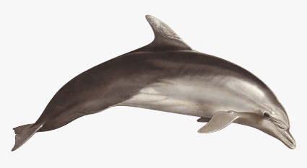
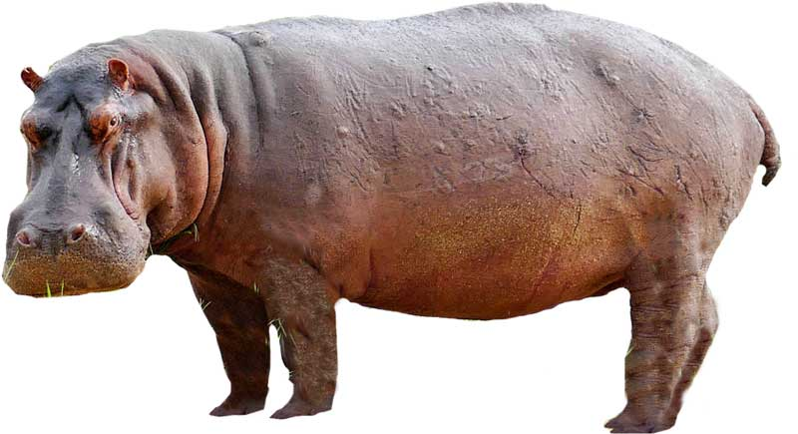 | 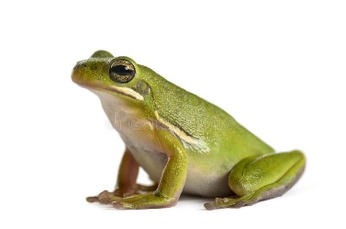 | 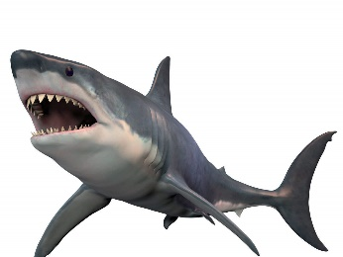

Correct answers | 1 | 2 | 3 | 4 | 5 | 6
Rating code | 1 | 2 | 4 | 5 | 7 | 7
Formal assessment tool: Teacher marks task and uses the conversion table to arrive at a rating code.

----------------------------------------------------------------------------------------------------------------------
dolphin | frog | crab
shark | crocodile | hippopotamus

School:_________________ Name of learner: __________________________
Grade 2 Term 2 Week 3-4
Life Skills: Routine activities Low support group
Topic: Creatures living in water Date: __________________
Educator:________________
Formal assessment goal: Set table with place mat, cutlery and mug/glass/cup

Task 4: Set table with place mat, cutlery and mug/glass/cup

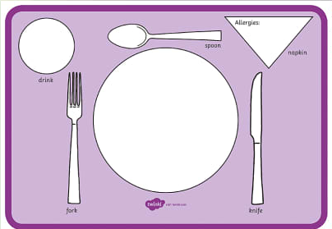

FORMAL ASSESSMENT RUBRIC
Description of competence | Not achieved | Elementary achievement | Moderate achievement | Adequate achievement | Substantial achievement | Meritorious achievement | Outstanding achievement
Rating code | 1 | 2 | 3 | 4 | 5 | 6 | 7
Routine activity  Set table with place mat, cutlery and mug/glass/cup | No attempt to participate in activity | Clear table | Put 1-3 articles in place | Put 4-5 articles in place | Put 6-7 articles in place | Put all articles in place | Put all articles in place and assist others

School:_________________ Name of learner: __________________________
Grade 2 Term 2 Week 3-4
Life Skills: Visual Arts Low support group
Topic: Creatures living in water Date: __________________
Educator:________________
Formal assessment goal: Experiment with colour, line, texture, tone, shape & space in 2 dimensions to express mood, feelings and ideas

Task 5: Create a picture of an octopus

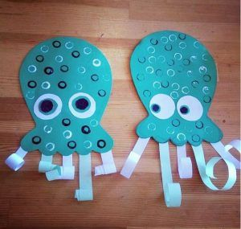

Formal assessment tool: Checklist

 | Experiment with: | Tick
 | one colour
 | more than one colour
 | line
 | texture
 | shape
 | space
 | Total ticks

Use conversion table to arrive at rating code:
Correct answers | 1 | 2 | 3 | 4 | 5 | 6
Rating code | 1 | 2 | 4 | 5 | 7 | 7

School:_________________ Name of learner: __________________________
Grade 2 Term 2 Week 3-4
Life Skills: Performing Arts Low support group
Topic: Creatures living in water Date: __________________
Educator:________________
Formal assessment goal: Convey feelings and ideas through facial expression and gesture

Task 6: Create and imitate sounds effects in stories made by water animals; snake, frogs, whales

Formal assessment tool: Checklist

 | Create and imitate sound effects made by: | Tick
 | one water creature
 | two water creatures
 | three water creatures
 | one water creature with facial expression
 | one water creature with facial expression and gesture
 | two water creature with facial expressions and gestures
 | three or more water creature with facial expressions and gestures
 | Total ticks

School:_________________ Name of learner: __________________________
Grade 2 Term 2 Week 3-4
Life Skills: Routine activity Low support group
Topic: Creatures living in water Date: __________________
Educator:________________
Formal assessment goal: Wash hands with soap and water and dry hands after using the toilet

Task 7: Wash hands with soap and water and dry hands after using the toilet
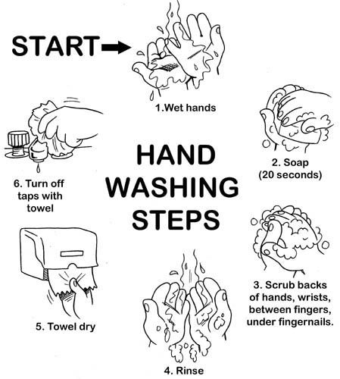

Formal assessment tool: Checklist

 | Activity performed by learner | Tick
 | Wet hands
 | Put soap on
 | Rub/scrub hands for 20 seconds
 | Rinse hands
 | Dry hands
 | Turn of the tap
 | Total ticks

Use conversion table to arrive at rating code:
Correct answers | 1 | 2 | 3 | 4 | 5 | 6
Rating code | 1 | 2 | 4 | 5 | 7 | 7

School:_________________ Name of learner: __________________________
Grade 2 Term 2 Week 5 - 7
Life Skills Low support group
Topic: Animals and their shelters Date: __________________
Educator:________________
Formal assessment goal : Identify animals and creatures that make own homes - such as birds, some bees, ants, spiders

Task 8: Match the animal with its shelter by drawing lines
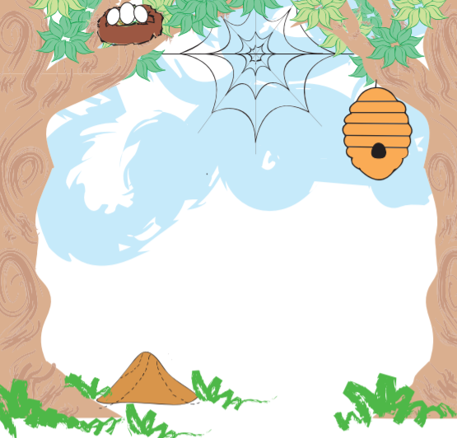
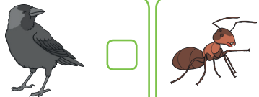 | 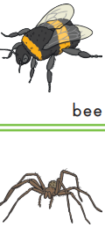
Formal assessment tool: Teacher marks the correct answers and uses conversion table to arrive at rating score.
Correct answers | 1 | 2 | 3 | 4 | 5
Rating code | 1 | 3 | 5 | 7 | 7
School:_________________ Name of learner: __________________________
Grade 2 Term 2 Week 5-7
Life Skills: Physical Education Low support group
Topic: Animals and their shelters Date: __________________
Educator:________________
Formal assessment goal: Balance on balance beam

Task 9: Balance on balance beam

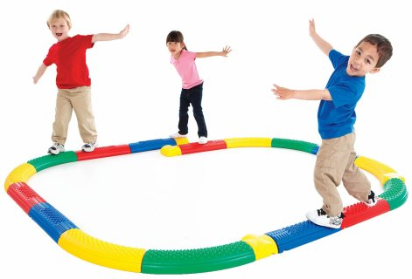

FORMAL ASSESSMENT RUBRIC
Description of competence | Not achieved | Elementary achievement | Moderate achievement | Adequate achievement | Substantial achievement | Meritorious achievement | Outstanding achievement
Rating code | 1 | 2 | 3 | 4 | 5 | 6 | 7
Physical Ed  Balance on balance beam | No attempt to participate in activity | Attempt to participate but hesitant to get on beam | Balance on beam and take 3 steps | Balance on beam and take 4-5 steps | Balance on beam and take 6-7 steps | Balance on beam and take 8-9 steps | Balance on beam and take many steps

School:_________________ Name of learner: __________________________
Grade 2 Term 2 Week 5-7
Life Skills: Visual Arts Low support group
Topic: Animals and their shelters Date: __________________
Educator:________________
Formal assessment goal: Explore and experiment with a wide variety of art materials, techniques and colour in spontaneous and creative way

Task 10: Use play dough to model animal freely - shaping, twisting and rolling
FORMAL ASSESSMENT RUBRIC
Description of competence | Not achieved | Elementary achievement | Moderate achievement | Adequate achievement | Substantial achievement | Meritorious achievement | Outstanding achievement
Rating code | 1 | 2 | 3 | 4 | 5 | 6 | 7
Visual Arts  Balance on balance beam | No attempt to participate in activity | Attempt to participate but hesitant to get on beam | Use one technique | Use 2 techniques | Shape, twist and roll. | Shape, twist and roll. Animal recognisable | Shape, twist and roll. Water animal recognisable. Use more than 2 colours
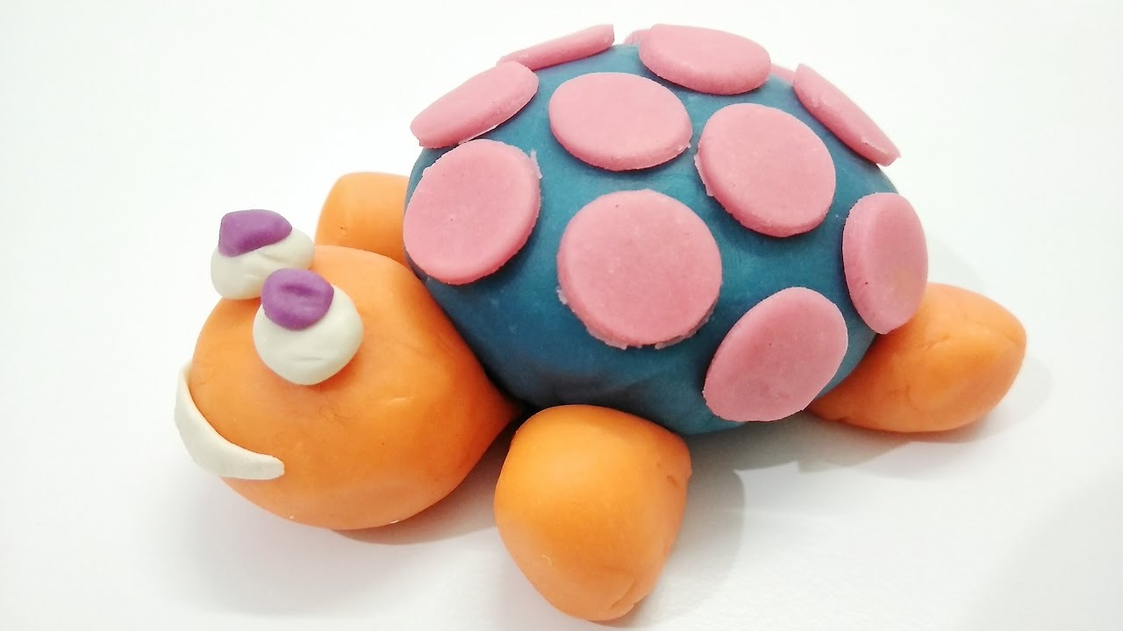

School:_________________ Name of learner: __________________________
Grade 2 Term 2 Week 5-7
Life Skills: Routine activities Low support group
Topic: Animals and their shelters Date: __________________
Educator:________________
Formal assessment goal: Tidy desk before break and home time

Task 11: Tidy desk before break and home time
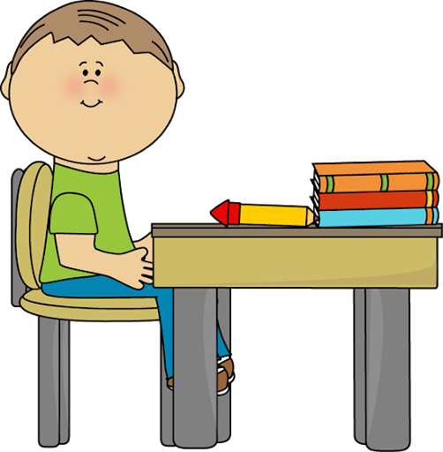

FORMAL ASSESSMENT RUBRIC
Description of competence | Not achieved | Elementary achievement | Moderate achievement | Adequate achievement | Substantial achievement | Meritorious achievement | Outstanding achievement
Rating code | 1 | 2 | 3 | 4 | 5 | 6 | 7
Routine activities  Tidy desk before break and home time for 5 days in a row | No attempt to participate in activity | Tidy desk 2 time per week, either before break or home time | Tidy desk 3 per week, either before break or home time | Tidy desk 4-6 times per week, either before break or home time | Tidy desk 7-9 times per week, either before break or home time | Tidy desk 10 per week, either before break or home time | Tidy desk every day for more than 5 days

School:_________________ Name of learner: __________________________
Grade 2 Term 2 Week 5-7
Life Skills Low support group
Topic: Animals and their shelters Date: __________________
Educator:________________
Formal assessment goal: Identify animals that find their homes and carry their homes

Task 12: Identify animals and creatures that find their homes and carry their homes. Circle the correct answers.
Crab |  | Owl |  | Snail |  | Turtle
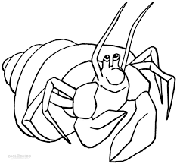 |  | 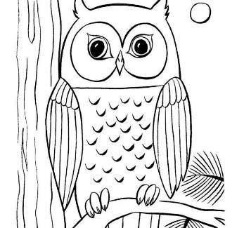 |  | 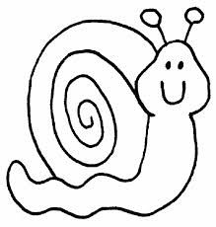 |  | 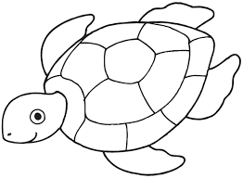
Find | Carry | Find | Carry | Find | Carry | Find | Carry

Squirel |  | Tortoise |  | Monkey |  | Crab
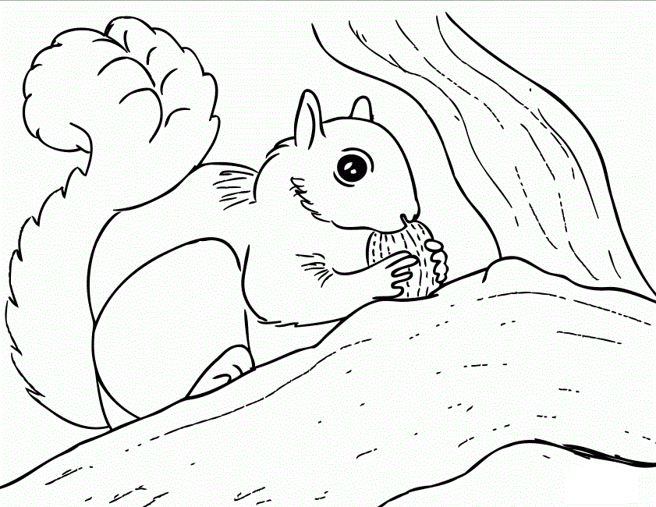 |  | 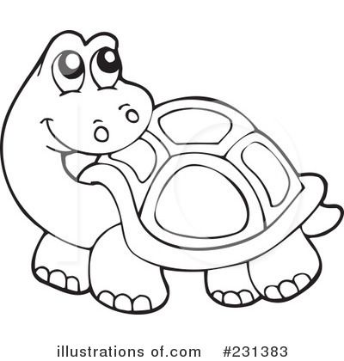 |  | 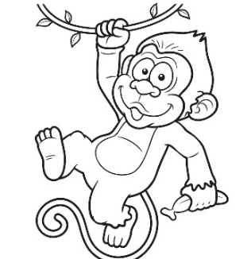 |  | 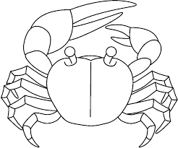
Find | Carry | Find | Carry | Find | Carry | Find | Carry

Formal assessment tool: Teacher marks the correct answers and uses conversion table to arrive at rating score.
Correct answers | 1 | 2 | 3 | 4 | 5 | 6 | 7 | 8
Rating code | 1 | 1 | 2 | 4 | 5 | 6 | 7 | 7

School:_________________ Name of learner: __________________________
Grade 2 Term 2 Week 5-7
Life Skills: Performing Arts Low support group
Topic: Animals and their shelters Date: __________________
Educator:________________
Formal assessment goal: Sing songs and make music to express a variety of ideas, feelings and moods

Task 13: Sing songs and make music to express ideas and feelings
Watch the video, sing the songs and make music:


http://youtube.com/watch?v=Pq8KhHlM-S0

Formal assessment tool:

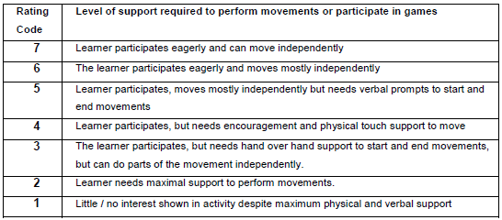

School:_________________ Name of learner: __________________________
Grade 2 Term 2 Week 5-7
Life Skills: Physical Education Low support group
Topic: Animals and their shelters Date: __________________
Educator:________________
Formal assessment goal: Participate in games

Task 14: Participate in games
Watch the video: Ten gross motor activities
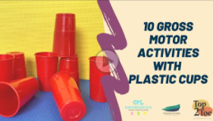
http://youtube.com/watch?v=9EnwOXeZRAc

Formal assessment tool:

School:_________________ Name of learner: __________________________
Grade 2 Term 2 Week 5-7
Life Skills: Free play Low support group
Topic: Animals and their shelters Date: __________________
Educator:________________
Formal assessment goal: Build structures/models with blocks

Task 15: Build structures/models with blocks, e.g. house, tower, animals.
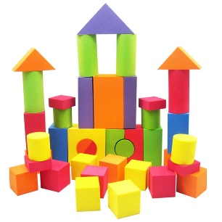 | 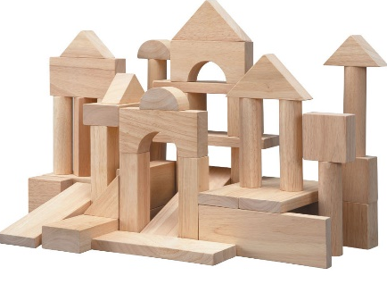
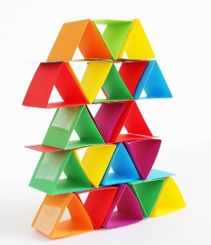 | 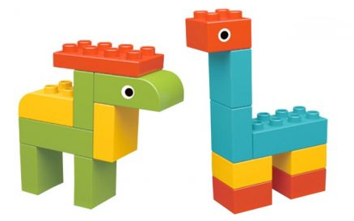

Formal assessment tool:
 | Activity performed by learner | Tick
 | The structure/model is recognisable
 | More than 10 blocks are used
 | Participate eagerly
 | Enjoy activity
 | Creative in building structures/models
 | Total ticks

Correct answers | 1 | 2 | 3 | 4 | 5
Rating code | 1 | 3 | 5 | 7 | 7

School:_________________ Name of learner: __________________________
Grade 2 Term 2 Week 5-7
Life Skills: Free play Low support group
Topic: Animals and their shelters Date: __________________
Educator:________________
Formal assessment goal: Throw and catch a ball

Task 16: Throw and catch a ball three times in 5 different activities

Watch the video: Throw and catch challenges (6)

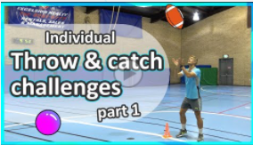

http://youtube.com/watch?v=FYS9o-__MwI

Formal assessment tool:

FORMAL ASSESSMENT RUBRIC
Description of competence | Not achieved | Elementary achievement | Moderate achievement | Adequate achievement | Substantial achievement | Meritorious achievement | Outstanding achievement
Rating code | 1 | 2 | 3 | 4 | 5 | 6 | 7
Free play  Throw and catch the ball 3 times in 5 activities | No attempt to participate in activity | Throw and catch the ball once in 1 activity | Throw and catch the ball 1-2 times in 2 activities | Throw and catch the ball 2-3 times in 2-3 activities | Throw and catch the ball 2-3 times in 4-5 activities | Throw and catch the ball 3 times in 4-5 activities | Throw and catch the ball 3 times or more in 5 activities

Addendum 3: Examples of memoranda
School:_________________ Name of learner: __________________________
Grade 2 Term 2 Week 1 - 2
Life Skills Low support group
Topic: Seasons Date: __________________
Educator:________________
Formal assessment goal: Know how seasons affect our food intake

Task 1: Colour the food pictures that you will eat during summer and winter
Summer
  ice cream | 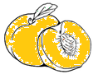peaches
  Milo | cold drink
Winter
  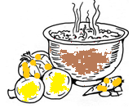soup | 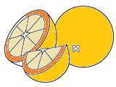oranges
  Hot choco-late | Christmas pudding
Correct answers | 1 | 2 | 3 | 4 | 5 | 6
Rating code | 1 | 2 | 4 | 5 | 7 | 7
Formal assessment tool: Teacher marks the correct answers and use the conversion table to arrive at a rating code

School:_________________ Name of learner: __________________________ Grade 2 Term 2
Week 1-2 Date: __________________ Life Skills Low support group
Topic: Seasons Educator:________________
Formal assessment goal: Know how seasons affect our clothes
Task 2: Cut, match and paste the clothes to wear during the seasons
Spring | Summer | Autumn | Winter

School:_________________ Name of learner: __________________________
Grade 2 1st year Term 2 Week 3-4
Life Skills Low support group
Topic: Creatures living in water Date: __________________
Educator:________________
Formal assessment goal: Identify and label water animals
Task 3: Identify and label water animals. Use the words in the word box.
crocodile | crab | dolphin
hippopotamus | frog | shark

Correct answers | 1 | 2 | 3 | 4 | 5 | 6
Rating code | 1 | 2 | 4 | 5 | 7 | 7
Formal assessment tool: Teacher marks task and uses the conversion table to arrive at a rating code.

----------------------------------------------------------------------------------------------------------------------
dolphin | frog | crab
shark | crocodile | hippopotamus

School:_________________ Name of learner: __________________________
Grade 2 Term 2 Week 5 - 7
Life Skills Low support group
Topic: Animals and their shelters Date: __________________
Educator:________________
Formal assessment goal : Identify animals and creatures that make own homes - such as birds, some bees, ants, spiders

Task 8: Match the animal with its shelter by drawing lines
Formal assessment tool: Teacher marks the correct answers and uses conversion table to arrive at rating score.
Correct answers | 1 | 2 | 3 | 4 | 5
Rating code | 1 | 3 | 5 | 7 | 7

School:_________________ Name of learner: __________________________
Grade 2 Term 2 Week 5-7
Life Skills Low support group
Topic: Animals and their shelters Date: __________________
Educator:________________
Formal assessment goal: Identify animals that find their homes and carry their homes

Task 12: Identify animals and creatures that find their homes and carry their homes. Circle the correct answers.
Crab |  | Owl |  | Snail |  | Turtle
Find | Carry | Find | Carry | Find | Carry | Find | Carry

Squirel |  | Tortoise |  | Monkey |  | Crab
Find | Carry | Find | Carry | Find | Carry | Find | Carry

Formal assessment tool: Teacher marks the correct answers and uses conversion table to arrive at rating score.
Correct answers | 1 | 2 | 3 | 4 | 5 | 6 | 7 | 8
Rating code | 1 | 1 | 2 | 4 | 5 | 6 | 7 | 7

